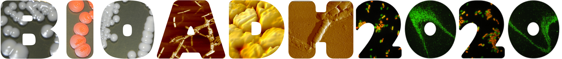

Colloque Bioadhésion, Biocontamination des surfaces

BioDyMIA, site Alimentec, Bourg en Bresse 26 et 27 mai 2020

INSCRIPTION

Nom: Prénom:

Position:

Master PhD Post-Doct
Chercheurs
Industriel

Laboratoire / Companie:

Adresse:

Email:

Téléphone N°:

PAIEMENT

400 euros* avant le 24 mars 2020
500 euros* après cette date *Association Loi 1901 – TVA not applicable Article 261,7-1°du CGI

Le prix comprend : l’inscription au colloque, les supports de communication, les repas et les pauses et la nuit d’hôtel en chambre individuelle du 26 au 27 mai

Chèque (BIOMAT) *

Send to: Reine BAREILLE - Secretary of BIOMAT
Université de Bordeaux - Case 84 - CS 61292 -
146, rue Léo Saignat - 33076 BORDEAUX Cedex
Email: reine.bareille@inserm.fr

Bon de commande (BIOMAT)
BP84- Université de Bordeaux
146 Rue Léo Saignat - 33076 BORDEAUX CEDEX
Email: reine.bareille@inserm.fr

Transfert interbancaire (BIOMAT):

Code APE: 9412Z N° SIRET: 339 491 888 00022N° SIREN: 339 491 888
BIC: BNPAFRPPMAN IBAN: FR76 3000 4003 2000 0101 9244 870

RIGHT TO IMAGE

We would like your permission to publish photographs where you can appear on the BIOMAT website. The photographs will not be communicated to other persons, sold or used for other uses than the diffusion on BIOMAT website. (Http://www.biomat.fr/). According to the law, free access to yours photographic data is guaranteed. You may at any time verify the use of your photographic data and have the right to withdraw your photographic data if you deem it useful.

Therefore, can you complete the form below. Many thanks in advance for your cooperation.

Madam, Sir:

Authorize BIOMAT to diffuse on its website photographs where I can appear.

Done at on

Signature

